5A – Mobile Phones – Lesson 01
Mobile Phone Plans – Reading Bills.

Name: _________________

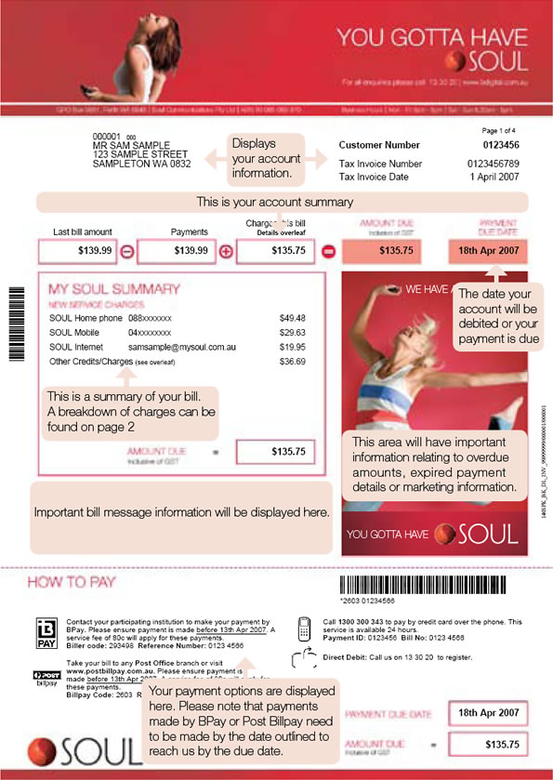
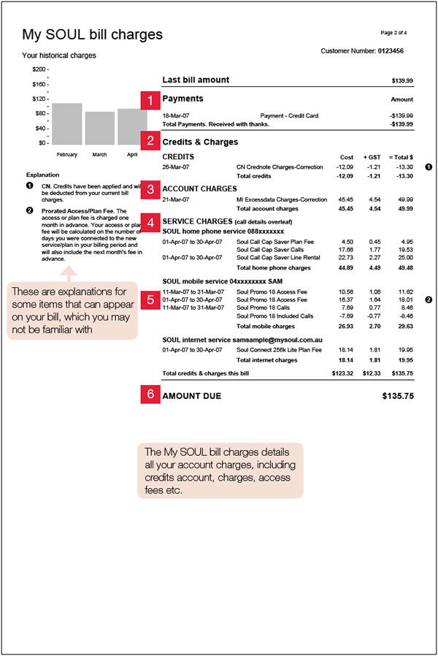
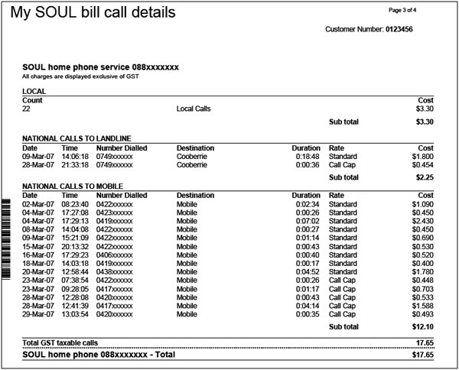

5A – Mobile Phones – Lesson 01
Mobile Phone Plans – Reading Bills.

Name: _________________
Page 1

- What other services are provided on this bill in addition to the mobile phone? [Hint: My Soul Summary]

- What methods of paying this bill are available? [Hint: How to pay]

- When is the Bill due to be paid?

- What is the tax invoice number? Why might you need it?

- What is a customer number and what can you use it for?

Page 2

- What method of payment has been used? [Hint: 1 Payments]

- What period does this bill cover for the mobile service? Is this the same as the Home service?

- What plan are they on for the Soul Internet Service?

Page 3

- Which Service is displayed on this page?

